**HORMISDALLEN SCHOOL - KYEBANDO**

**PRE- PLE SET 10 EXAMINATIONS, 2023**

**PRIMARY SEVEN SOCIAL STUDIES**

**Duration: 2 Hours 15 Minutes**

**NAME: ______________________________________________ STREAM: _________**

INDEX NO.

EMIS NO.

**SECTION A: (40 MARKS)**

1. What is the direction of South Sudan from Uganda?

………………………………………………………………………………………………….

2. What name is given to the steep sides of a rift valley?

…………………………………………………………………………………………………

3. Give any one way modern communication promotes trade.

………………………………………………………………………………………………….

4. Name any example of a planted forest in Uganda.

………………………………………………………………………………………………….

5. State any one way of controlling poverty in Africa.

………………………………………………………………………………………………….

6. Mention the most important natural resource in East Africa.

………………………………………………………………………………………………….

7. Give the reason why the League of Nations was formed after the First World War .

………………………………………………………………………………………………….

8. Give the reason why most game parks are located with in the Savannah vegetation ..

………………………………………………………………………………………………….

9. ·· State any one problem faced by people in public offices in Uganda .

…………………………………………………………………………………………………..

10. Give any one reason why a Television is not widely used as a means of communication in most parts of Uganda .

………………………………………………………………………………………………….

11. Write any one advantage of using water transport over air transport .

………………………………………………………………………………………………….

12. Write UBOS in full.

………………………………………………………………………………………………….

13. State one role of a family doctor.

………………………………………………………………………………………………….

14. Give one reason why the governments of East Africa should preserve Stone

Age sites.

………………………………………………………………………………………………….

15. Give any one reason why a wind sock is kept at the airport.

………………………………………………………………………………………………….

16. State any one reason why elections are important in a country like Uganda .

………………………………………………………………………………………………….

17. Name the continent that is not suitable for human settlement.

………………………………………………………………………………………………….

18. State any one economic importance of Fort Jesus .

………………………………………………………………………………………………….

19. Name any one importance of small scale industries to the people of Uganda .

………………………………………………………………………………………………….

20. Mention any one weather instrument kept in a Stevenson screen .

………………………………………………………………………………………………….

21. How is the Uganda Revenue Authority important in the economic development of Uganda?

………………………………………………………………………………………………….

22. How was Lake Ngami formed?

………………………………………………………………………………………………….

23. State one proper method of managing wastes in the environment.

………………………………………………………………………………………………….

24. Write any one way children can help to maintain security at home .

………………………………………………………………………………………………

25. State the economic similarity between the Hamites and Nilo- Hamites .

…………………………………………………………………………………………………

26. Draw a map symbol of a seaport in the space provide below.

27. In which Stone Age did early man discover farming?

………………………………………………………………………………………………….

28. State any one way the people of Uganda have benefited from the creation of many districts .

………………………………………………………………………………………………….

29. Why did Kabaka Muteesa I invite Christians missionaries to Buganda?

………………………………………………………………………………………………….

30. Name the feature that separates Madagascar from Africa mainland.

………………………………………………………………………………………………….

31. Give the reason why the people in Kisoro district terrace their land.

………………………………………………………………………………………………….

32. Mention the major reason why pastoral tribes never formed kingdoms.

………………………………………………………………………………………………….

33 .. Why did the Lukiiko refuse to send representatives on LEGCO?

………………………………………………………………………………………………….

34. How was the formation of Lake Albert similar to that of Lake Edward?

………………………………………………………………………………………………….

35. How do people benefit from the coming of foreign investors?

………………………………………………………………………………………………….

For questions 36-40, answer Either Christianity or Islamic but not both.

36. Either: State one value of baptism to Christians.

………………………………………………………………………………………………….

Or: State one value of circumcision to Muslims .

………………………………………………………………………………………………….

37. Either: Write any one symbof in Christianity .

………………………………………………………………………………………………….

Or: Write any one symbol in Islam.

………………………………………………………………………………………………….

38. Either: What lesson do you as P. 7 pupil learn from the life of Job?

………………………………………………………………………………………………….

39. Either: Give any one reason why Christians should observe fasting.

………………………………………………………………………………………………….

Or: Give any one reason why Muslims should observe fasting.

………………………………………………………………………………………………….

40. Either: Mention any one way HIV/AIDS has caused suffering in Christian families today.

………………………………………………………………………………………………….

Or: Mention any one way HIV/AIDS has caused suffering in Muslims families today.

………………………………………………………………………………………………….

**SECTION B: (60 MARKS)**

41. a Name any two member states of EAC.

i)…………………… ……………….………………………………………………………

ii)…………………… ……………….………………………………………………………

. (b) Give any two benefits of EAC to member states.

i)…………………… ……………….………………………………………………………

ii)…………………… ……………….………………………………………………………

42. a) To which organ of the government do the police belong?

………………………………………………………………………………………………….

b) State any two roles of the legislature arm of arm of government.

i)…………………… ……………….………………………………………………………

ii)…………………… ……………….………………………………………………………

c How was the work of LEGCO similar to that of the parliament in Uganda today?

………………………………………………………………………………………………….

43. a) What is climate?

………………………………………………………………………………………………….

b) How does latitude affect the climate of Africa?

………………………………………………………………………………………………….

c) Mention any two human activities which affect the climate of an area negatively.

i)…………………… ……………….………………………………………………………

ii)…………………… ……………….………………………………………………………

44. The diagram below show the formation of a certain type of physical feature.

study it carefully and answer the questions that follow.

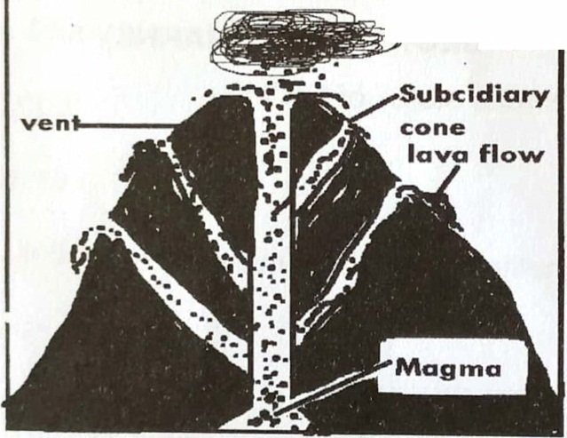

~h--~sh

a) Name the physical feature shown above.

………………………………………………………………………………………………….

b) Mention the process by which the above physical feature was formed .

………………………………………………………………………………………………….

c) Give any one danger faced by people living near the above physical feature .

………………………………………………………………………………………………….

d) Why are the areas near the above physical feature good for agriculture?

………………………………………………………………………………………………….

45. a) Mention any two reasons why Uganda trades with USA.

. i)…………………… ……………….………………………………………………………

ii)…………………… ……………….………………………………………………………

b) Give any two challenges Uganda faces due to her geographical location. i)…………………… ……………….………………………………………………………

ii)…………………… ……………….………………………………………………………

46.Benedict is a civil servant who earns Sh.500,000 below is his monthly expenditure. Study is carefully and answers the questions that follow.

1. Rent Sh.100,000

2. Transport Sh.10,000

3. Food Sh. 70,000

4. School fees Sh.200,000

a) What type of budget is shown above?

………………………………………………………………………………………………….

b) Give one advantage of the budget you have named in 46 (a) above .

……………………………………………………………………………………………….

c) Mention any two sources of government revenue.

i)…………………… ……………….………………………………………………………

ii)…………………… ……………….……………………………………………………

47. Write short notes on the following personalities.

a) Capt. Frederick Lugard

………………………………………………………………………………………………….

b) Sir Hesketh Bell

………………………………………………………………………………………………….

c) Sir John Hathon Hall

………………………………………………………………………………………………….

d) Chief Awich of Payera

………………………………………………………………………………………………….

48. The pie chart below shows a country's earnings. Use it to answer the questions that follow.

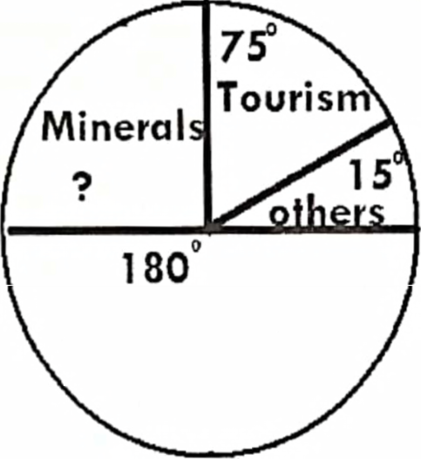

Agriculture

a) Which is the major export earner of this country?

………………………………………………………………………………………………….

b) How many degrees do minerals take?

………………………………………………………………………………………………….

c) Mention the second biggest export earner of this country.

………………………………………………………………………………………………….

d) State any one benefit the above country gets from agriculture.

………………………………………………………………………………………………….

49. a) Mention any one way people have misused the environment.

. ………………………………………………………………………………………………….

b) Apart from deforestation, give any two human activities that have Jed to environmental degradation.

i)…………………… ……………….………………………………………………………

ii)…………………… ……………….………………………………………………………

c) State any one way in which you can keep the environment clean.

…………………………………………………………………………………………………..

50. Study the sketch map of Africa below and answer the questions that follow.

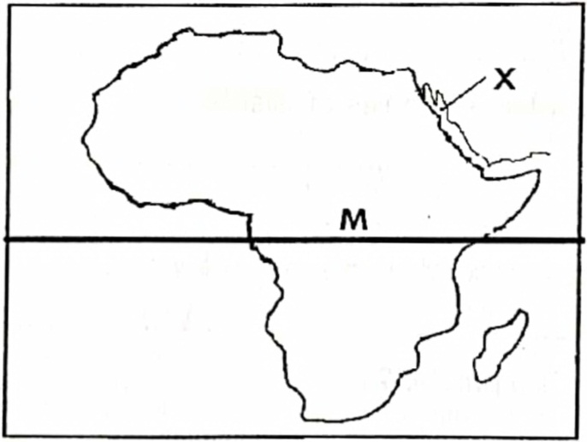

a) Name the water body marked X.

………………………………………………………………………………………………….

b) Name any one island country found in the Indian Ocean .

………………………………………………………………………………………………….

c) Name the island country crossed by line marked M

………………………………………………………………………………………………….

d) Name the continent that neighbours Africa to the north .

……………………………………………………………………………………………….

**For questions 51-55, answer Either Christian or Islam on a number.**

51. Either: a) What is a talent?

………………………………………………………………………………………………….

b) Mention any two examples of talents.

i)…………………… ……………….………………………………………………………

ii)…………………… ……………….………………………………………………………

. c) Give any importance of talents to primary children.

………………………………………………………………………………………………….

OR: a) What is a talent?

………………………………………………………………………………………………….

b) Mention any two examples of talents.

i)…………………… ……………….………………………………………………………

ii)…………………… ……………….……………………………………

. c) Give any importance of talents to primary children .

………………………………………………………………………………………………….

52. Either: a) Who is a prophet?

………………………………………………………………………………………………….

b) Name any two examples of prophets in Christianity.

i)…………………… ……………….………………………………………………………

ii)…………………… ……………….………………………………………………………

c) Give any one way God communicates to people apart from prophets.

………………………………………………………………………………………………….

Or: a) Who is a prophet?

………………………………………………………………………………………………….

b) Name any two examples of prophets in Islam.

i)…………………… ……………….………………………………………………………

ii)…………………… ……………….………………………………………………………

c) Give any one way Allah communicates to people apart from prophets .

………………………………………………………………………………………………….

53. For all candidates:

a) What term is used to mean the bringing back of the lost friendship?

………………………………………………………………………………………………….

b) Give any two importance of having friends. ·

i)…………………… ……………….………………………………………………………

ii)…………………… ……………….………………………………………………………

c) How can you a P.7 pupil bring back the lost friendship?

…………………………………………………………………………………………………

54. **Either: Match the items in list A to those list B correctly**

**List A List B**

Matthias Betrayed Jesus

Thomas Replaced Juda Iscariot

John Doubted the resurrection of Jesus

Judas Iscariot Most beloved apostle

a) Matthias …………………………………

b) Thomas …………………………………

c) John …………………………………

d) Judas Iscariot …………………………………

Or: **Match the items in list A to that list B correctly**

**List A List B**

Amina The first caliph of Muhammad

Halimah Uncle of Muhammad

Abu-Talib Mother of Muhammad

Abubakar Foster mother

a) Amina …………………………………

b) Halimah …………………………………

c) Abu-Talib …………………………………

d) Abubakar …………………………………

**55. Either: a)** What is **authority?**

………………………………………………………………………………………………….

b) Write any two types of authority.

i)…………………… ……………….………………………………………………………

ii)…………………… ……………….………………………………………………………

. c) Mention any one way leaders misuse authority.

………………………………………………………………………………………………….

**Or:** a) What is **authority?**

………………………………………………………………………………………………….

b) Write any two types of authority.

i)…………………… ……………….………………………………………………………

ii)…………………… ……………….………………………………………………………

c) Mention any one way leaders make good use of their authority .

………………………………………………………………………………………………….

**End**

.